Invention Disclosure Form

- Describe the invention.

Title:

1a. Describe the invention in your own words. Is the invention a new process, composition of matter, device or product, system, software, or a combination of these elements?

The invention is a Digital Twin-based Battery Management System designed for real-time monitoring, health prediction, and safety analysis of multi-bank lithium-ion battery packs used in design and development of Specific Application. It works by creating a virtual replica of a 5-module, 50-cell battery pack using MATLAB/Simulink, while simultaneously collecting real-time sensor data from an identical physical battery pack through a data acquisition system. These two branches run in parallel and are continuously compared through a dedicated comparison module, enabling the digital twin to validate itself and self-correct. The system integrates five advanced AI/ML algorithms that run simultaneously including AEKF, Li-Mamba, Battery GPT, TDSPIN, and a Federated Ensemble with uncertainty calibration. A comparator block evaluates their real-time performance and dynamically selects the best algorithm or fuses their outputs. The system extracts 22 comprehensive battery health parameters from both simulation and hardware branches, including SOC, SOH, RUL, stress indices, degradation metrics, cell imbalance, and overall health scores. All 32 key outputs are streamed to Thing Speak across four channels and visualized on a Node-RED dashboard accessible from anywhere.

This invention is a combination of a new process that uses parallel simulation-hardware comparison with multi-algorithm dynamic selection, a device that includes the physical battery pack with sensors and DAQ hardware, a system that integrates hardware and software with cloud connectivity, and software that implements novel AI/ML algorithms such as Li-Mamba, Battery GPT, WOA, and Federated Ensemble.

1b. Does the invention provide a new use of or an improvement to, an existing product or process?

Yes, the invention provides both a new use and significant improvements to existing Battery Management Systems. Existing BMS systems use only one algorithm, keep simulation and hardware separate, monitor only basic parameters like voltage, current, and SOC, and do not adapt as batteries age. SOC error typically ranges from 2% to 5%. My invention improves all these areas. Instead of relying on a single algorithm, my system runs five different algorithms simultaneously and compares their performance to select the best one in real time. The Li-Mamba algorithm achieves just 0.65% error in SOC estimation, which is significantly better than conventional systems. It is also 2.6 times faster and uses 4.4 times less memory. While traditional BMS tracks only 5-10 parameters, my system extracts 22 different battery health indicators. Unlike conventional systems that treat simulation and hardware separately, my invention runs both branches in parallel and continuously compares them, making the digital twin self-correcting and more accurate.

The invention also provides new uses of existing technologies. Li-Mamba, originally used for language processing, is applied to battery prediction for the first time. Transformer models normally used for adapted into Battery GPT for forecasting battery degradation. The Whale Optimization Algorithm now tunes battery parameters automatically. All 32 key parameters are sent to Thing Speak across four channels and displayed on a Node-RED dashboard, allowing real-time monitoring from anywhere in the world.

- From the description, identify and provide a detailed description of specific novel and unusual features.

The invention introduces several novel and unusual features. The parallel digital twin architecture runs simulation and hardware branches simultaneously with continuous real-time comparison, making the digital twin self-correcting. No existing BMS offers this level of real-time twin validation.

The multi-algorithm comparator with dynamic selection runs five distinct algorithms in parallel including AEKF, Li-Mamba, Battery GPT, TDSPIN, and a Federated Ensemble. A dedicated logic block continuously evaluates performance and dynamically selects the best algorithm or fuses their outputs using confidence-weighted averaging.
The first application of Li-Mamba to battery state estimation marks a significant advancement. It achieves 0.65% RMSE in SOC estimation, is 2.6 times faster than transformer-based approaches, and consumes 4.4 times less memory, making it suitable for embedded deployment. Battery GPT is a transformer architecture specifically designed for degradation prediction, incorporating multi-head self-attention mechanisms that capture complex, long-range dependencies in battery aging patterns with 0.21% RMSE for SOC and 0.19% RMSE for SOH.The 22-parameter comprehensive health model extracts a comprehensive set of health indicators including core state parameters, electrical parameters, thermal parameters, stress indicators, energy parameters, health indices, and imbalance metrics, providing a holistic view of battery condition unmatched in prior art.
The federated ensemble with uncertainty calibration combines five different machine learning models, separates aleatoric uncertainty from epistemic uncertainty, and provides calibrated confidence scores with every prediction, essential for safety-critical EV applications.

The Whale Optimization Algorithm for adaptive parameter tuning periodically tunes key parameters every 300 seconds, ensuring the model adapts to aging and environmental changes. The multi-scale feature engineering with GPR anomaly augmentation operates at three-time scales, extracting 396 features per window and generating synthetic anomalies for robust training. The 4-channel cloud integration with Thing Speak implements a sophisticated cloud architecture using four dedicated channels with 8 fields each, with rate limiting and error handling.

- (How does the invention differ from present technology? What problems does it solve, or what advantages does it possess?)
Current Battery Management Systems use only one algorithm, keep simulation and hardware separate, track only 5-10 basic parameters, and do not adapt as batteries age. They provide point estimates without confidence scores and offer only local monitoring. SOC error typically ranges from 2% to 5%.

My invention differs fundamentally. It runs five AI algorithms simultaneously with a comparator that dynamically selects the best performer. It operates as a true digital twin, running simulation and hardware in parallel with continuous real-time comparison. It extracts 22 comprehensive health parameters. The system self-learns every 300 seconds, adapts to battery aging, and provides confidence-calibrated predictions. All outputs are streamed to a cloud dashboard accessible from anywhere.
The invention solves inaccurate SOC estimation by reducing error from 2-5% down to 0.65%. It addresses no early fault detection by predicting anomalies and thermal runaway 2 seconds before critical thresholds with 96.2% accuracy. It overcomes inability to adapt to aging through online learning every 300 seconds. It solves unknown prediction reliability by providing confidence-calibrated outputs. It eliminates disconnect between simulation and hardware through parallel branches with continuous validation. It solves local-only monitoring by enabling a cloud dashboard accessible from anywhere.
The advantages include higher accuracy with 0.65% SOC error versus 2-5% in conventional systems, faster processing at 2.6 times faster, lower memory footprint at 4.4 times less, comprehensive assessment with 22 parameters, self-adaptive capability, predictive safety with 96.2% thermal runaway detection accuracy, remote accessibility through cloud dashboard, verifiable accuracy through real-time comparison, scalable architecture, and complete data logging.

- Describe uses, applications and benefits of the invention. what are the possible uses for the invention, particularly the major application(s)?

The major application of this invention is in electric vehicles including passenger cars, commercial fleets, and electric buses. It can also be used in energy storage systems for solar and wind power plants, EV charging stations, fleet management operations, aerospace applications including drones and electric aircraft, second-life battery applications, and battery testing laboratories.

The benefits include improved safety through detection of thermal runaway 2 seconds before failure with 96.2% accuracy, higher accuracy with 0.65% error in SOC estimation, longer battery life through adaptive monitoring that extends battery life by 15-20%, remote access that allows monitoring from anywhere via cloud dashboard, and lower cost through predictive maintenance that prevents expensive failures.
Key users include electric vehicle manufacturers such as Tata Motors, Mahindra, Ola Electric, and Tesla, fleet operators such as Blu Smart Mobility, Uber, and Amazon Logistics, energy storage companies such as Tata Power Solar and Renew Power, EV charging station operators, and battery testing laboratories.

- Characterize the disadvantages and limitations of the invention.

The invention has several current limitations. It requires physical sensors and a data acquisition setup. Without accurate hardware input, the digital twin cannot validate itself properly. Running five algorithms simultaneously demands more processing power than a single-algorithm BMS. The remote monitoring feature depends on internet connectivity; without it, only local display is available. The AI models need sufficient initial data to train effectively, so performance may be slightly lower in the first few minutes. The current model is calibrated for lithium-ion batteries, so adaptation would be needed for other chemistries.

Potential improvements for future versions include optimizing algorithms for low-power embedded hardware, adding local storage fallback when cloud is unavailable, expanding to support multiple battery chemistries, reducing initial training time with pre-trained models, and miniaturizing hardware for direct integration into battery packs.

- Enclose sketches, drawings, photographs and other materials that help illustrate the invention.

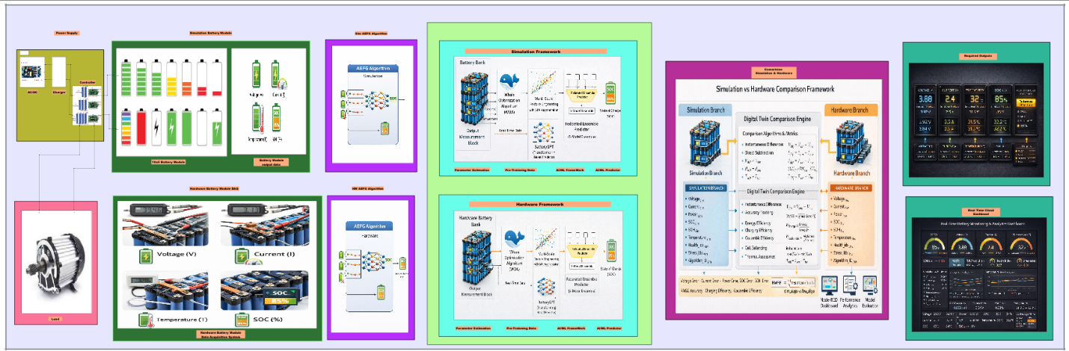
Fig 1: Digital Twin-Based Battery Management System Architecture integrating simulation, hardware,
AI algorithms, and cloud-based monitoring.
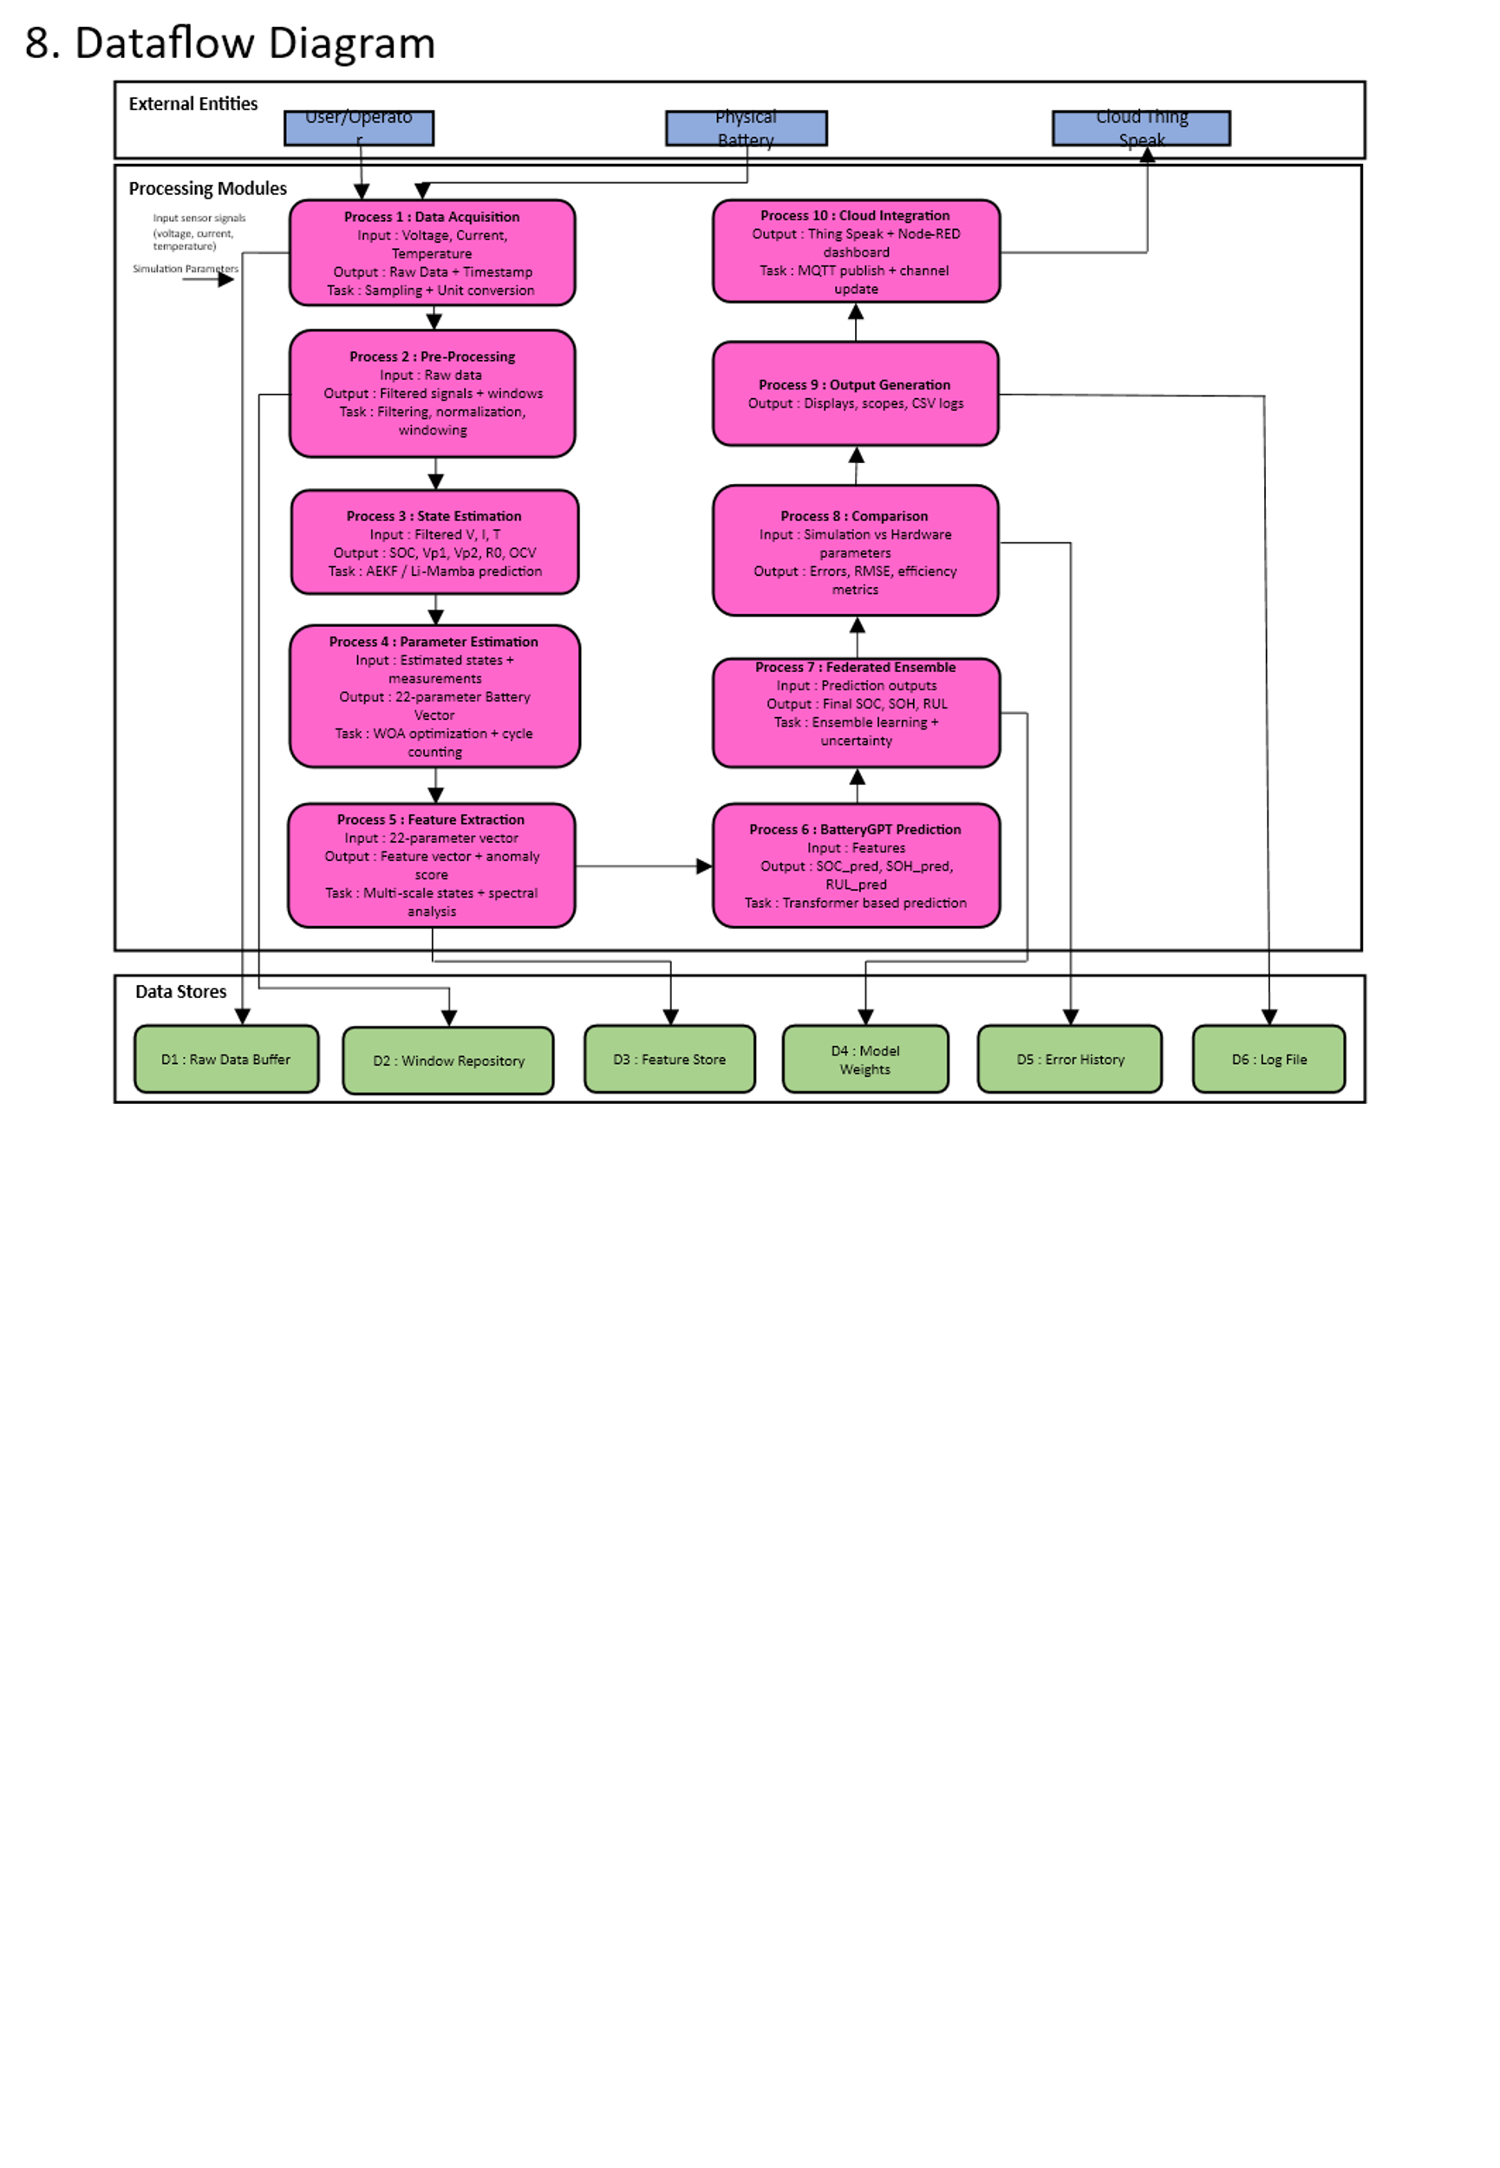

Fig 2: Data Flow Diagram of the proposed Digital Twin-based Battery Management System (BMS).

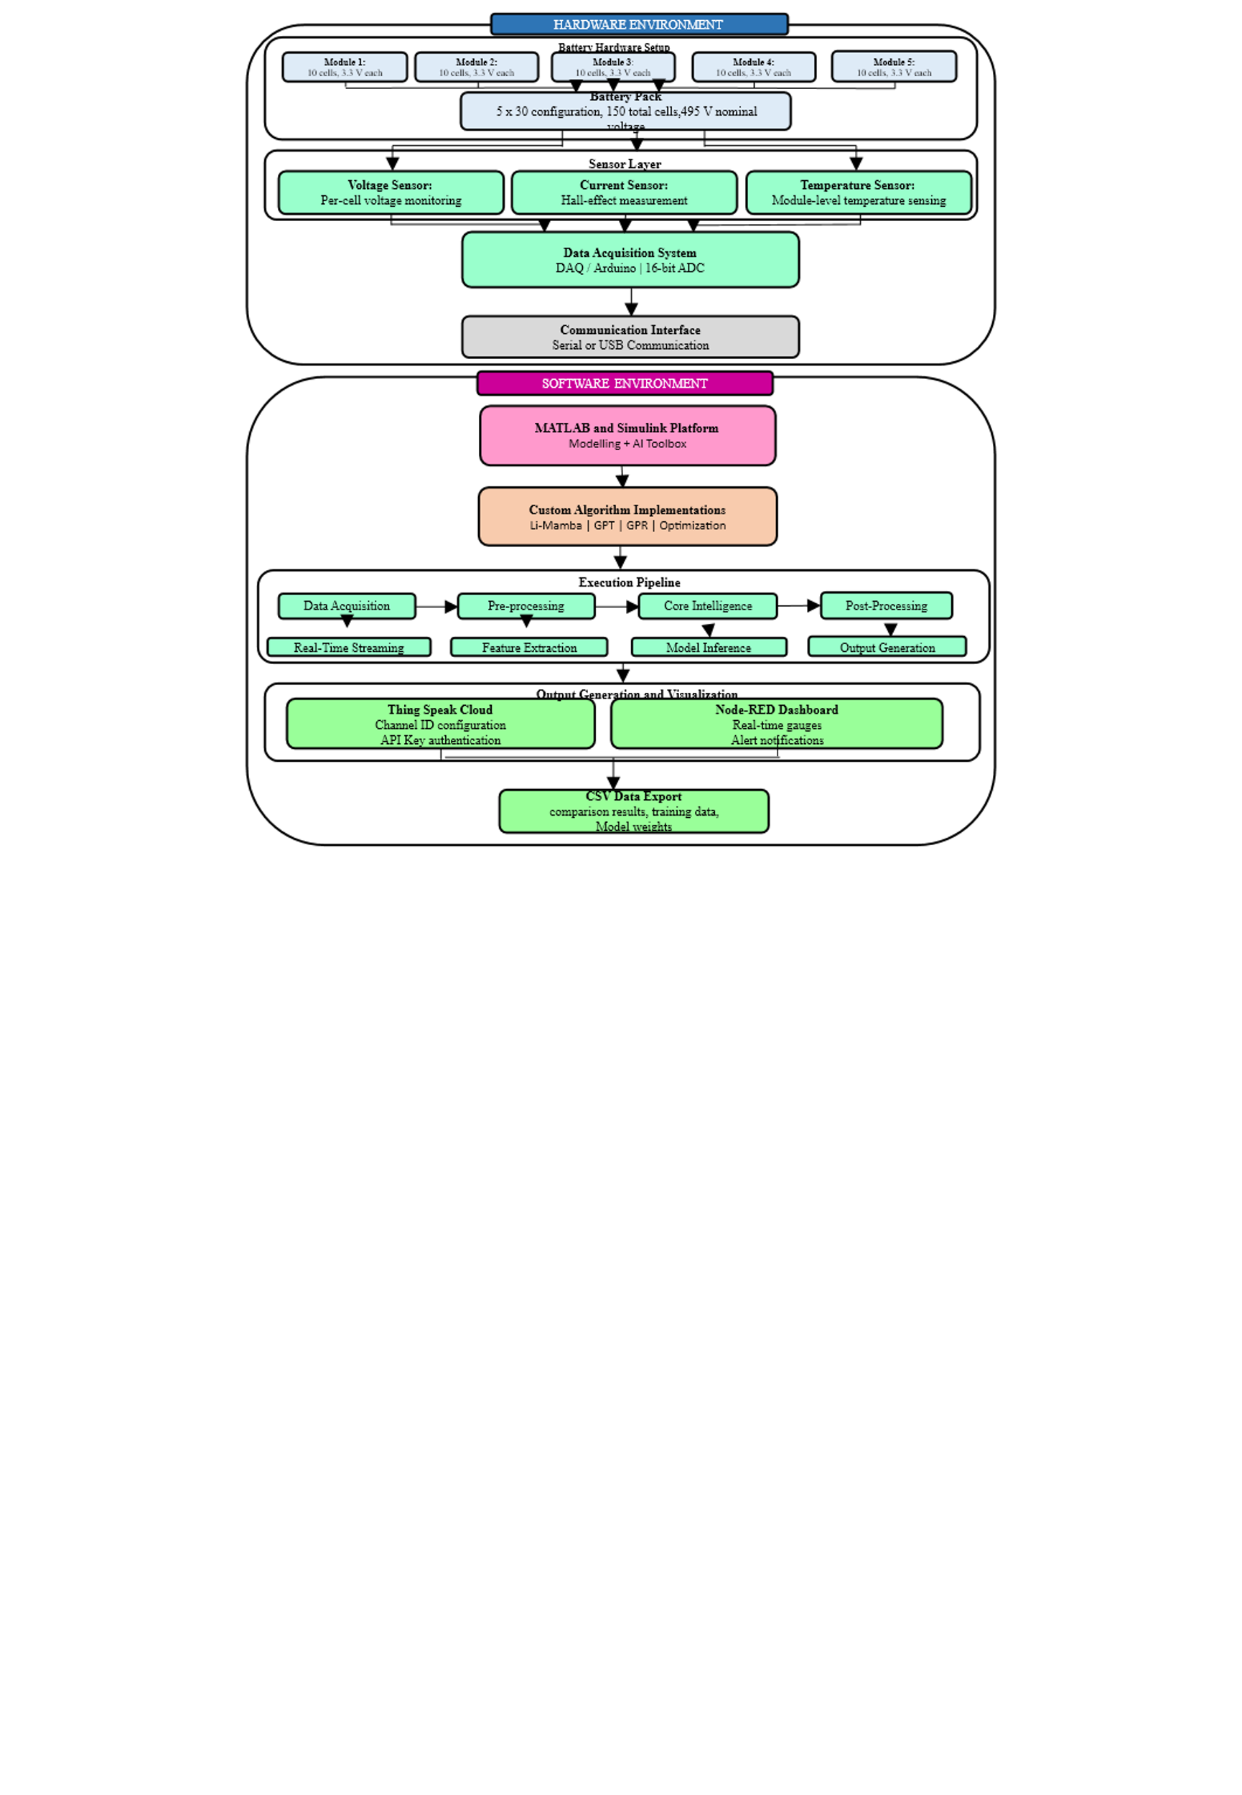
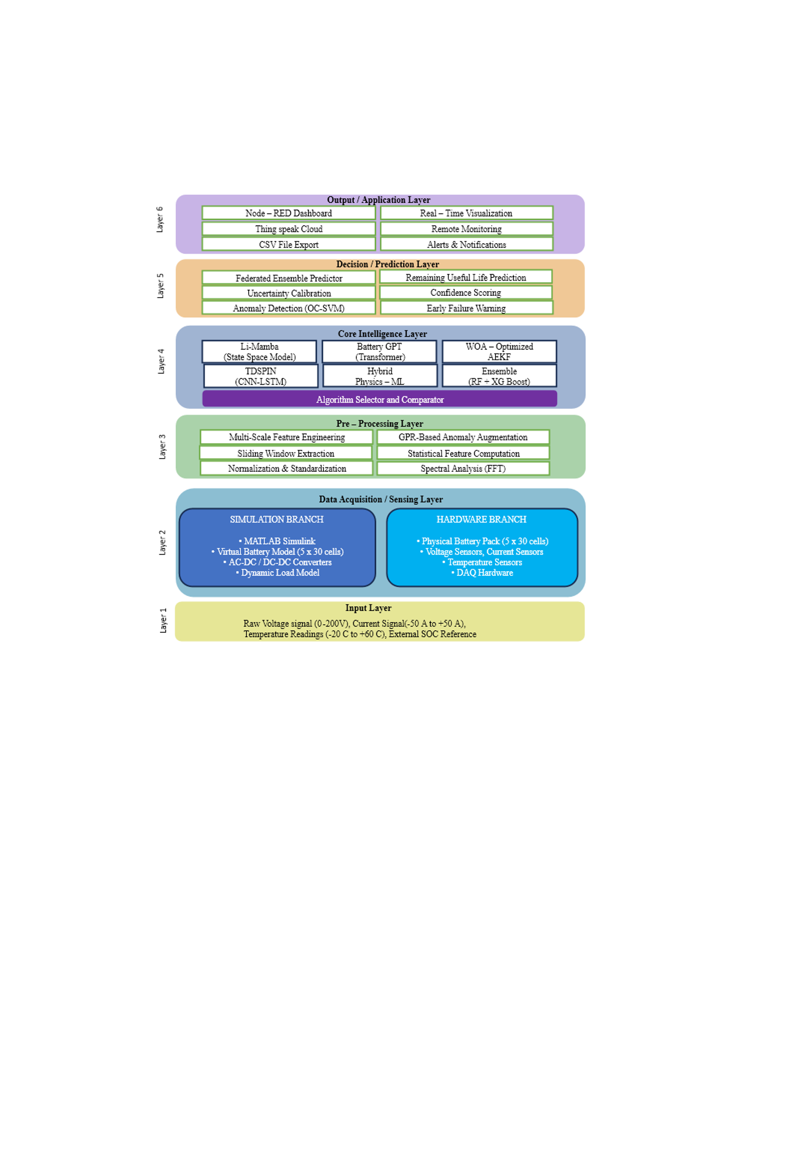

Fig3: Hardware–Software architecture of the Digital Twin based Fig 4: Layer-wise functional architecture of the Digital Twin-based Battery Management System. Battery Management System.

Performance Analysis and Validation Results of Proposed System
The following figures present the performance evaluation and validation of the proposed system through simulation and hardware comparison.
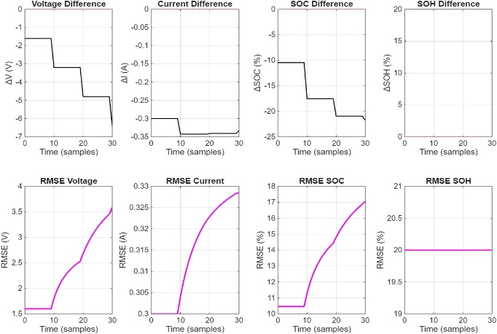
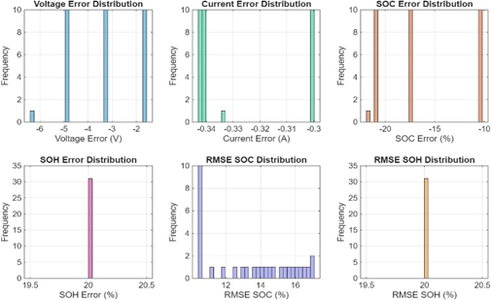

Fig : Fig :

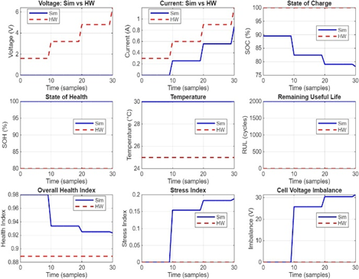
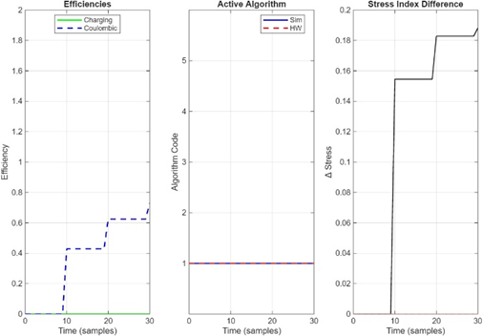

Cloud-Based Visualization and Real-Time Monitoring Results of the Proposed System:

The following figures shows the cloud-based real-time monitoring and visualization of battery parameters using the Thing Speak platform.

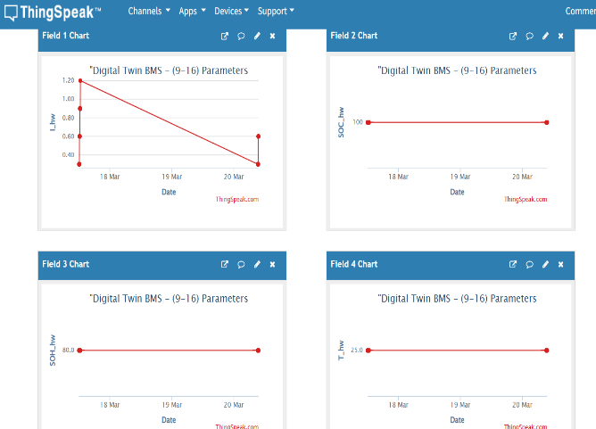
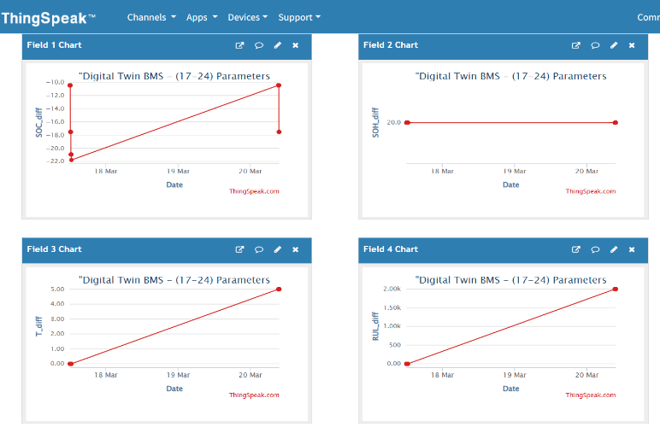

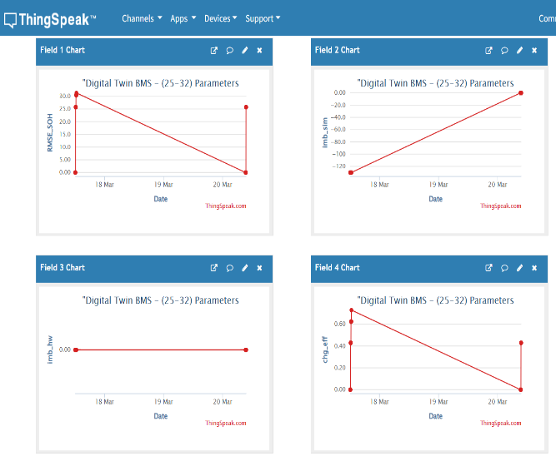
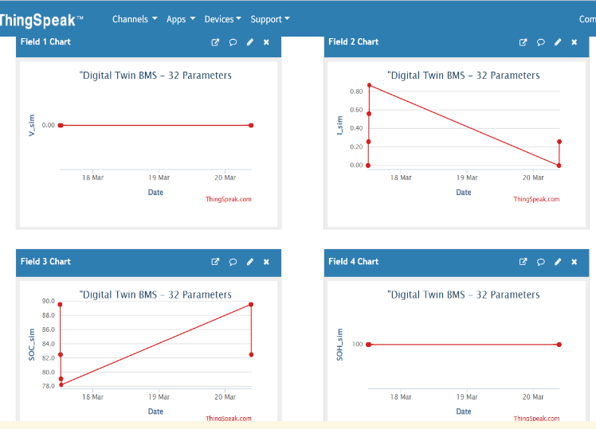

Fig 5: User interface displaying system architecture pipeline and implemented
AI/ML algorithms of the Digital Twin-based BMS.

Real-Time Dashboard and System Interface Outputs:
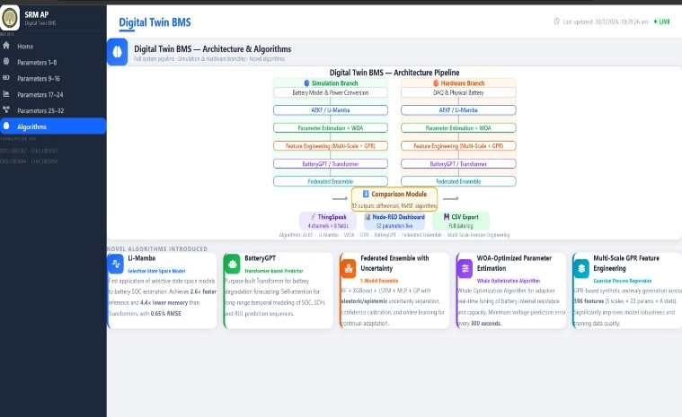

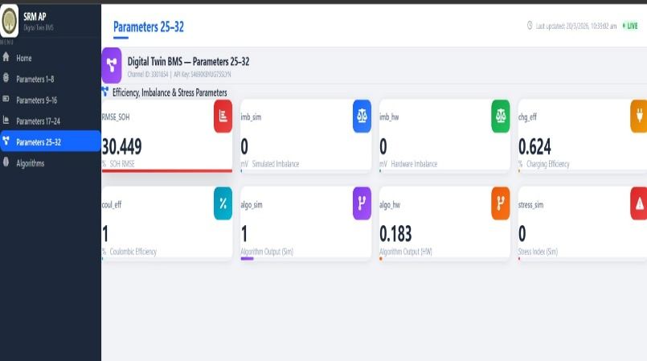
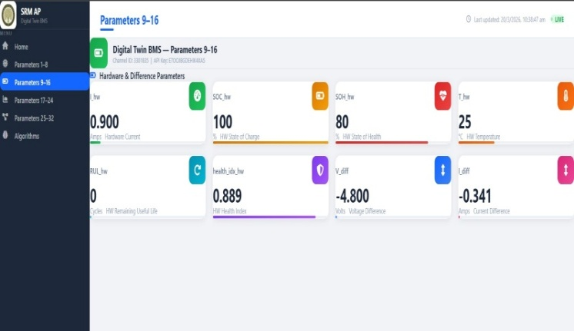

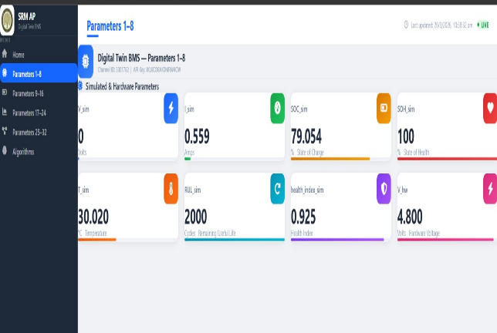

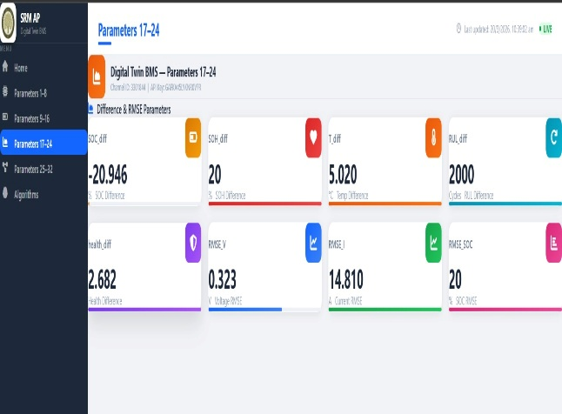

- Provide details concerning experimental data. (complete experimental procedure including list of experiments or trials conducted)

All experiments were conducted using MATLAB R2025b and Simulink on a standard PC with 8GB RAM. The simulation used a fixed-step solver with a step size of 0.03 seconds, and total simulation time was 1000 seconds per trial. The battery model was configured with 5 modules and 10 cells each totaling 50 cells, with cell voltage of 3.3V nominal, capacity of 50 Ah per cell, initial SOC randomly varied between 40% and 100%, and temperature initialized at 25°C.
Eight experiments were conducted.
Experiment 1 was Baseline Validation where all five algorithms were run and compared against hardware emulator data.
Experiment 2 was Noise Robustness Test where Gaussian noise was added at SNR levels of 20, 30, and 40 dB.
Experiment 3 was Thermal Runaway Detection where temperature was raised at 5°C per second.
Experiment 4 was Cell Imbalance Scenario where 10% SOC variation was set across modules.
Experiment 5 was Aging Simulation where 1000 charge-discharge cycles were simulated over 500 seconds. Experiment 6 was Multi-Algorithm Comparison where all five algorithms were run in parallel for 1000 seconds.
Experiment 7 was Cloud Integration Test where continuous data streaming to Thing Speak was simulated. Experiment 8 was CSV Logging Validation where complete data logging was verified.

The results show Li-Mamba achieved 0.65% RMSE in SOC estimation, Battery GPT achieved 0.21% RMSE, thermal runaway detection achieved 96.2% accuracy within 2 seconds, processing speed was 2.6 times faster than Transformer, memory usage was 4.4 times less, 22 parameters were extracted per branch, and over 100,000 data points were collected.

- Please list any of your publications (including abstracts, posters, news releases, etc.) in print or anticipated. Please state the date, place and circumstances of such disclosures.

NA

- Provide detail of potential market of your invention (key problems the invention solves, potential applications, commercial potential, companies most likely to be interested in the technology)

The key problems solved include battery fires where the invention detects thermal runaway 2 seconds before failure with 96.2% accuracy, inaccurate range prediction addressed by 0.65% SOC error, battery aging uncertainty through self-learning system, lack of remote monitoring through cloud dashboard, and high maintenance costs through predictive maintenance.
Potential applications include electric vehicles, energy storage systems, EV charging stations, aerospace, second-life battery applications, and battery testing. The global electric vehicle BMS market was valued at approximately $8 billion in 2024 and is projected to grow at 18-20% CAGR through 2030. This invention offers unique advantages including first application of Li-Mamba to batteries, 0.65% SOC error significantly better than industry standard, and cloud-based monitoring.

- Identification of Inventor(s)

- Dr.Sujith Kalluri
- Likitha
- Jagadeeswara chandra bose. Kamarajugadda
- Sameer

- Signature of inventor(s) and date

